***PAAREES PERFUMES***

***VERSACE***

***FOR UNISEX***

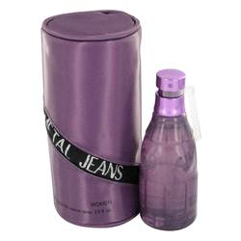

# 

# *Metal Jeans*

## *Description:*

Metal Jeans by Versace Cologne. Make a statement and stand out from the crowd wearing Metal Jeans for men. Created by the famous Versace design house in 2001, this powerful scent is classified as a spicy lavender fragrance. It features a mixture of watery notes, oak moss, watermelon and jasmine over a base of musk. Metal Jeans is perfect for work or play. Splash it on to accentuate your masculinity and create a strong impression wherever you go. It is recommended for daytime use